**Code Retrospective**

Working in a software development team was an amazing experience for learning as well as reassurance that I am working hard toward the right thing. I learned a lot about working on a project as a team and what things to do to try and make it successful. Things like being vocal in team meetings and asking for help instead of spinning your wheels and wasting your time, in order to make sure quality work gets done.

**Frontend/User quality work**

I did a lot of work on the front end and work to make the user experience better. I worked to add a password reset to user profiles. That included making all of the pages that the user would use as well as creating the automatic email the system would send to user if the problem email was in the database. I also did other things to smooth the user experience like making the 404 page. Most of these things were handled by the auth.views in Django and other things that are built into Django to help developers make a good product for the user. The learning and work came from taking these tools and learning how to use them and implement them successfully into our project. It was a lot of reading of the Django documentation and stackoverflow coupled with trial and error to make this work.

**Working with Django/MVT**

Working with Django and the MVT framework in general was a huge challenge and was fun to dive into. I’ve never worked with a system like this before and had to do a lot of research to really figure out how it worked. I wrote a view in python for the user account that worked to get the user location, as well as a javascript script to find the user’s location using the new features in html5 and passing that to a Django form to save the user's location data to the server. I also learned about the built in databases auth tables for keeping user records. I also wrote some code to extend the user database and make a customisable userprofile This was also my first experience working with API’s which was exciting. There are so many cool and useful things I found and even more to learn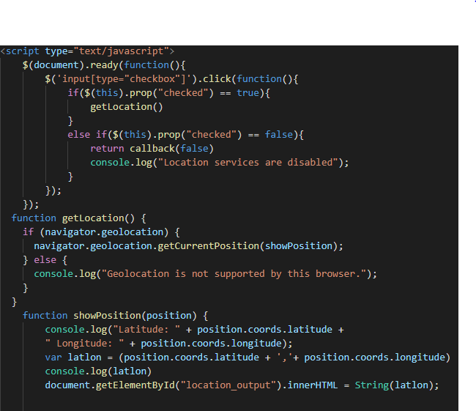

This a snippet that checks the users location after getting permission from a checkbox on the user profile page then inserts that into a form.

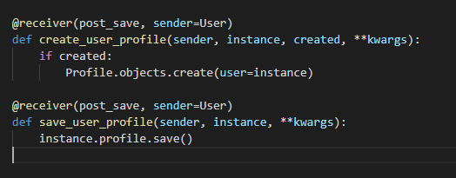

This I wrote to extend the User model into a customizable UserProfile model.

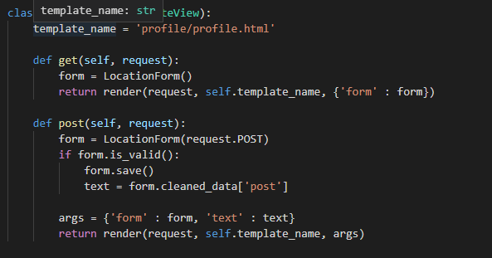

This is view I created to handle a form for updating changes to the UserProfile model when the user’s profile is edited or updated.

The rest of the work I did besides writing a whole thing that used two different APIs to try and find and update user locations automatically that I could never get to work properly, were the things like the password reset and 404 page. Those two thing were just using html and the Django forms, extends, and load static shortcuts to make dynamic, uniform pages. The only thing tricky about them really was getting the settings and urls right so they actually worked.

Overall this whole experience was very positive, I can’t wait to get on to the C# project and eventually make this my career.